Dental Report Card

Halcyon Veterinary Hospital
1636 Benton Road
Bossier City, LA 71111
Phone: 318-584-7049

Patient: _______________________________________ Date: _____________

Activity | - Keep your pet quiet and confined for a period of _______ days. No running, jumping, or playing rough with others while your pet heals.  - Many pets may be sedate, dizzy, or not want to eat for 12-24 hours after anesthetic  - An endotracheal tube has been placed during the procedure and may cause a slight sore throat or light cough for a few days.
Medication | - No medication needed at this time.  - Give medication(s) as directed on label.
Diet | - Normal food and water upon arriving home. Not wanting to eat for 12-24 hours after anesthetic is normal.  - We performed extractions today  - Feed soft food for _____ days  - Recommended diet:
Follow Up  Recommendations | - Recheck in ______ days on ________________ at____________.  - No recheck required  - Before and After pictures of your pets teeth will be emailed to __________________________  - Top 3 options on keeping your pet’s teeth happy and healthy.  - 1) Brushing teeth. Daily brushing is the best way to protect your pet’s dental health using a pet safe enzymatic toothpaste.  - 2) Dental Hygiene Chews like OraVet. Giving an OraVet chew to your pet once a day is one of the simplest ways to prevent bacterial attachments and to help reduce plaque and calculus.  - 3) Water additives like C.E.T AQUADENT. Adding this to your pet’s water bowl helps to prevent plaque accumulation and freshens your pet’s breath with every drink. Just 2 teaspoons to a quart of water provides another layer of protection for your pet’s dental health.  - All of your pet’s dental products can also be found on our online store!
Special Instructions: _________________________________________________________________
______________________________________________________________________

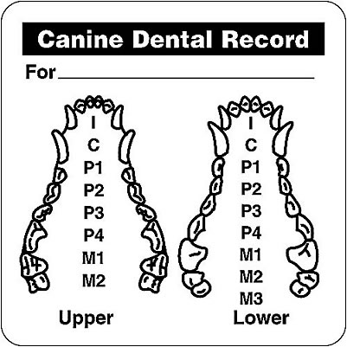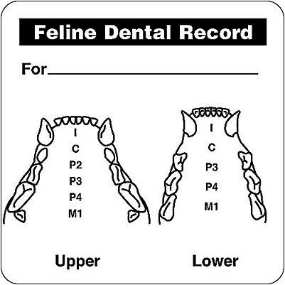

PP-Periodontal Pocket X-Extracted Tooth G-Gingivitis
DR-Doxirobe Gel Applied AT-Attrition C-Consil (Bone Graft)
0-Missing Tooth ED-Enamel Defect F-Flap Surgery

